**Trike + Cargo**

Market Analysis

* E-commerce Boom
* Urban Congestion: In densely populated cities, trike plus cargo vehicles offer a flexible and maneuverable alternative to traditional delivery vans.
* Sustainability and Environmental Concerns
* Government Incentives
* Cost-Effectiveness: Lower operating costs, including fuel and maintenance, make trike plus cargo vehicles an attractive option for businesses.
* Electric Three-Wheeler Market: This market is projected to grow from **USD 4.73 Billion in 2022 to USD 5.9 billion by 2030**, exhibiting a compound annual growth rate (CAGR) of 11.10% during the forecast period (2024 - 2030).
* Electric Cargo Bike Market: This market is anticipated to reach **USD 4,781 million in 2024 and grow at a CAGR of 14.2% during the forecast period to reach a value of USD 18,052.7** million by 2034.

Competitors

| **Competitor** | **Strengths** | **Weaknesses** | **Opportunities** | **Threats** |
| --- | --- | --- | --- | --- |
| **ElectraTrike** | Lightweight, modular design. | Limited range and payload capacity. | Focus on advanced batteries. | Competitors with IoT-based solutions. |
| **Piaggio Ape E-Xtra FX** | Affordable, urban logistics focus. | Low modularity for attachments. | Expand industrial compatibility. | New electric trikes with similar pricing. |
| **Bajaj RE Electric** | Affordable, well-established service. | Basic design; lacks IoT features. | Adding IoT/AI-based fleet management tools. | Rapid innovation in electric vehicles. |
| **Linde AGVs** | Autonomous, highly efficient for indoor use. | High cost, limited outdoor usability. | Expand mixed-environment capabilities. | Other automated solutions gaining traction |

Development / Design

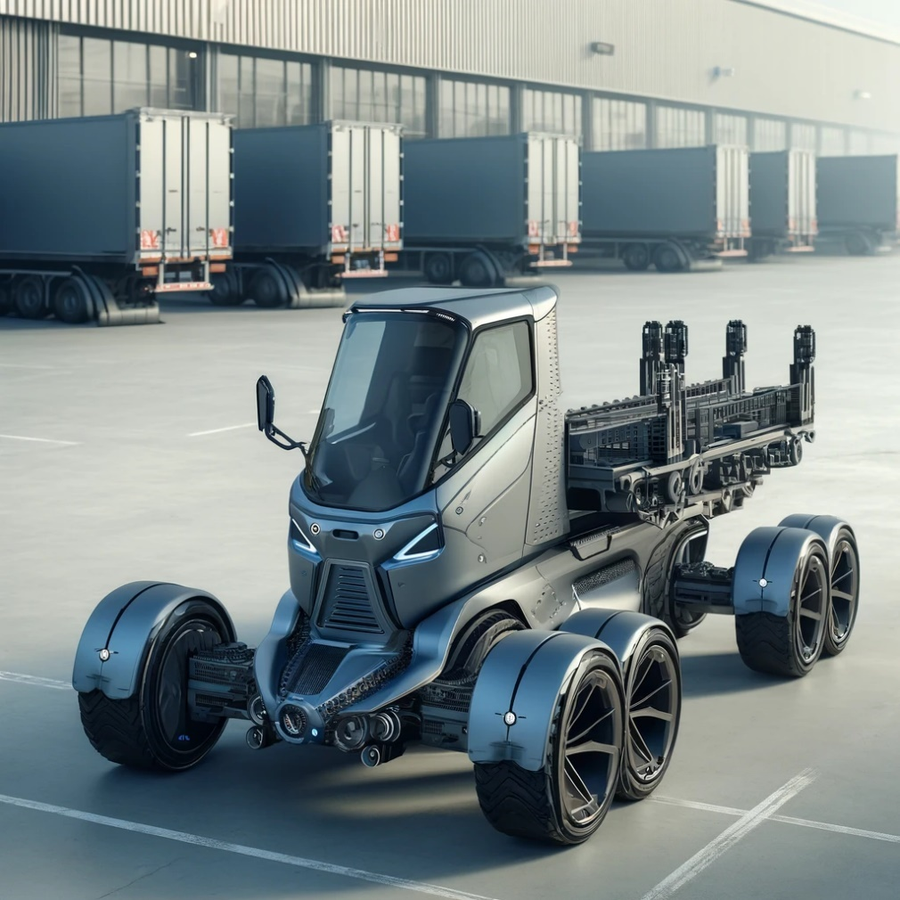

codeStart  
  |  v  
[Login Page] ---> [Role Selection: Admin/Driver]  
  |  v  
[Dashboard]  |  v  
+-------------------------------+  
| Modules                      |  
|-------------------------------|  
| 1. Vehicle Tracking          |  
|    -> GPS for real-time      |  
|       location updates       |  
| 2. Load Management           |  
|    -> Input vehicle capacity |  
| -> Monitor trailer loads |  
| 3. Energy Monitoring |  
| -> Track battery status |  
| -> Charging alerts |  
| 4. Maintenance Scheduling |  
| -> Schedule servicing |  
| -> Maintenance reminders |  
| 5. Fleet Analytics |  
| -> Usage reports |  
| -> Performance insights |  
| 6. Alerts & Notifications |  
| -> Real-time updates |  
+-------------------------------+  
|  
v  
[User Action/Selection]  
|  
v  
[Process Data and Display Results]  
|  
v  
[End]

1. **Vehicle Tracking Module**

* **Core Features**:
  + Real-time GPS location tracking of each trike in the fleet.
  + Route optimization using integrated maps.
  + Geo-fencing to alert if a vehicle goes off-course.
  + Historical route logs for analysis.
* **Advanced Features**:
  + Collision detection and alerts.
  + Integration with traffic data for dynamic route adjustments.

**2. Load Management Module**

* **Core Features**:
  + Input maximum load capacity for each trike and its trailers.
  + Monitor real-time load weights using integrated sensors.
  + Smart load distribution across multiple trailers.
  + Alerts for overload or uneven load distribution.
* **Advanced Features**:
  + Predictive load balancing for maximizing efficiency.
  + Integration with warehouse systems for automated load planning.

**3. Energy Monitoring Module**

* **Core Features**:
  + Real-time battery status tracking.
  + Charging station locator with route suggestions.
  + Energy consumption analysis to identify inefficiencies.
  + Alerts for low battery and estimated range left.
* **Advanced Features**:
  + Smart charging schedules based on vehicle usage patterns.
  + Integration with renewable energy sources (e.g., solar charging).

**4. Maintenance Scheduling Module**

* **Core Features**:
  + Automated reminders for periodic maintenance tasks (e.g., battery check, tire replacement).
  + Log of past repairs and costs for each vehicle.
  + Real-time fault detection from IoT sensors (e.g., motor issues, brake wear).
* **Advanced Features**:
  + Predictive maintenance using AI to foresee potential failures.
  + Integration with vendor services for part replacements.

**5. Fleet Analytics Module**

* **Core Features**:
  + Generate usage reports for each vehicle and driver.
  + Track fleet performance metrics like distance covered, fuel savings, or energy usage.
  + Cost analysis for operations, maintenance, and energy.
* **Advanced Features**:
  + Visual dashboards with KPIs for quick decision-making.
  + AI-driven insights to optimize fleet performance over time.

**6. Alerts and Notifications Module**

* **Core Features**:
  + Instant notifications for critical events (e.g., low battery, maintenance issues, route deviation).
  + Alerts for scheduled servicing or overloading.
  + Driver and admin-specific notifications.
* **Advanced Features**:
  + Customizable alert preferences (e.g., email, SMS, app push).
  + Smart alerts prioritizing critical over non-urgent issues.

**7. Driver Management Module**

* **Core Features**:
  + Driver profiles with work history and performance tracking.
  + Task assignments with delivery or route details.
  + Real-time communication between drivers and admin.
* **Advanced Features**:
  + Driver behavior analytics (e.g., speed, braking habits).
  + Gamification to encourage safer driving and better performance.

**8. User Access and Role Management Module**

* **Core Features**:
  + Role-based access control (Admin, Driver, Manager).
  + Define permissions for data visibility and actions.
* **Advanced Features**:
  + Multi-factor authentication for enhanced security.
  + Logs of user activity for auditing purposes.

**9. Inventory Management Module (Optional)**

* **Core Features**:
  + Track inventory items being transported.
  + Alerts for damaged or lost items.
* **Advanced Features**:
  + Integration with warehouse inventory systems for real-time sync.

**10. Emergency Response Module**

* **Core Features**:
  + SOS button for drivers to report emergencies.
  + Real-time location sharing with emergency contacts.
* **Advanced Features**:
  + Automatic alerts for crashes or vehicle malfunctions detected by sensors.
  + Emergency assistance dispatch integration

1. **General Specifications**

* **Type**: Futuristic industrial electric trike with trailer compatibility.
* **Load Capacity**:
  + Trike: 200 kg.
  + Trailers (up to 5-6 trailers): Additional 300 kg.
  + Total Capacity: 500 kg.
* **Dimensions**:
  + Trike: 2.5m (length) x 1.2m (width) x 1.5m (height).
  + Trailer: 1.5m (length) x 1m (width) x 0.8m (height).

**2. Powertrain and Battery**

* **Motor**:
  + 5 kW (6.7 HP) brushless electric motor.
  + Torque: 120 Nm (sufficient for industrial loads).
* **Battery**:
  + 72V, 50 Ah lithium-ion battery.
  + Battery life: Up to 8 hours under full load.
  + Range: 80-100 km per charge (with regenerative braking).
* **Charging**:
  + Fast charging: 2-3 hours (DC).
  + Standard charging: 6-8 hours (AC).

**3. Chassis and Suspension**

* **Frame**:
  + Heavy-duty steel chassis with corrosion resistance.
  + Lightweight aluminum alloy trailers for load optimization.
* **Suspension**:
  + Front: Telescopic fork suspension.
  + Rear: Dual shock absorbers with load adjustment capabilities.
* **Brakes**:
  + Front: Hydraulic disc brakes.
  + Rear: Regenerative braking + disc brakes.

**4. Tires and Wheels**

* **Tires**:
  + Heavy-duty, puncture-resistant industrial tires.
  + Trike: 16-inch tires.
  + Trailers: 14-inch tires.
* **Traction**: All-terrain tread for indoor and outdoor industrial use.

**5. Connectivity and Dashboard**

* **Dashboard**:
  + Digital touchscreens display with real-time vehicle stats (speed, battery, load status).
  + Integrated GPS and navigation system.
* **Connectivity**:
  + Bluetooth and Wi-Fi for app integration.
  + IoT-enabled for remote monitoring via a fleet management app.
* **Smart Features**:
  + Geofencing alerts.
  + Maintenance reminders.
  + Driver authentication using RFID or biometric scanners.

**6. Safety Features**

* **Lights**:
  + LED headlight, taillight, and indicators for visibility.
* **Stability Control**: Anti-roll and load-balancing mechanisms.
* **Emergency Features**:
  + Panic button for drivers.
  + Automatic alerts for battery overheating or load mismanagement.
* **Cameras and Sensors**:
  + Rearview camera for reversing.
  + Proximity sensors for collision avoidance.

**7. Trailer System**

* **Attachment System**:
  + Quick-connect modular system for attaching trailers.
  + Automatic locking mechanism for stability.
* **Load Distribution**: Sensors for equal load balancing across trailers.
* **Payload Surface**: Flatbed with adjustable panels for various cargo types.

**8. Environmental Adaptability**

* **Weatherproofing**: IP65-rated chassis and electrical components for rain and dust resistance.
* **Operating Temperature**: -10°C to 50°C.
* **Noise Level**: <40 dB for quiet operation in sensitive industrial areas.

**9. Optional Add-ons**

* Solar panel integration for auxiliary charging.
* Swappable battery system for uninterrupted operation.
* Autonomous driving module for pre-mapped industrial routes.

**Sales**

The target audience for the Trike Cargo Trailer Electric includes:

1. Urban Commuters: Individuals who need a practical and eco-friendly solution for transporting goods and supplies within urban environments.
2. Small Businesses: Companies involved in local delivery services, food and beverage distribution, or retail operations that require a reliable and cost-effective cargo transportation option.
3. Outdoor Enthusiasts: Adventure seekers and outdoor enthusiasts who need a versatile trailer for carrying camping gear, sports equipment, or recreational items.
4. Eco-Conscious Consumers: Individuals who prioritize environmentally friendly transportation options and seek an electric-powered solution for their cargo hauling needs.
5. Local Service Providers: Professionals such as landscapers, gardeners, or maintenance workers who require a convenient and efficient means of transporting tools and equipment for their daily work.

**Feedback**

User Experience

Warranty / maintenance services

Parts replacement

Upgrades customized.

Customer support channel

On the go help